Northwest MISGA Group Local Rules
A "Blended Tee" configuration is used. Play all Par 4s from the Gold tees and the Par 3s and Par 5s from the Green tees. Players may also elect to play from the gold tees exclusively or the Green tees exclusively. In summary- players have 3 choices of tees- Gold, Blended, or Green.
The course has numerous (nearly every hole) un-mowed/environmentally protected areas. Treat them as a lateral penalty area and drop at point of entry. (You are not to hit your ball from these areas.) See reverse for exact locations of these areas on each hole.
There is one Water (Yellow) Penalty Area (but not marked as such)on Hole #5. A tiny creek bed with stones on both sides ofthe fairway. Ifneeded take reliefunder USGA Rule 17. Id(l) or (2) and a one (l ) stroke penalty.
Lateral (Red) Penalty Areas — Unfortunately often not marked by Red Stakes
Holes 1, 4, 7, 8, &13 have a creek bordering the hole. Holes 2, 4, 5, & 7 have a tree line to left of fairway prior to environmental area.
1 (one) — Stroke Penalty: See USGA Rule 17 for options in Lateral Penalty Areas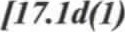
The difference between an environmental area and a penalty area is that you may, if you choose, attempt to hit the ball out of the penalty area.
Depicted below are the holes with both Lateral Penalty Areas (indicated by red) and Environmental area (black).
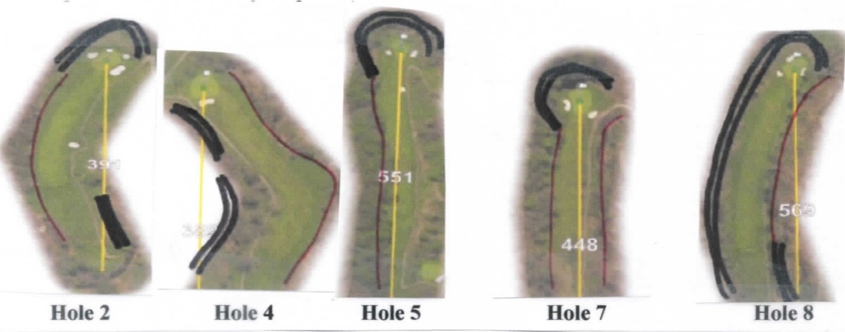
Out of Bounds: Not marked but only the Parking Lot and road ways are Out of Bounds. Lost Ball: Player may choose to drop ball in the fairway nearest vicinity where the ball was deemed to have been lost (or out of bounds) under a 2 stroke penalty. Drop Areas — None.

Immovable Obstructions:
- All cart paths, Yardage Markers, Tee Markers, Posts and Fences, Ball Washers, Water Coolers, Electrical Boxes, Sprinkler heads, Sprinkler Boxes, and Porta a Potty on Hole #3.
Take RELIEF from Interference when ball lies in or on the Obstruction or when the Obstruction interferes with the player's stance or the intended swing path.
Movable Obstructions:
- Movable Obstructions — such as Rakes, Stakes, and Ropes — which affect the ball's lie, your stance, or area of intended swing may be moved without penalty. * All Stones in Bunkers are to be considered movable obstructions.

Embedded Ball:
Anywhere "through the green" a ball which is embedded in its own pitch mark in the ground (except in a hazard or in loose sand) may be lifted without penalty, cleaned, and dropped within one (1) club length of the spot where it was embedded, but not nearer the hole. The ball, when dropped, must first strike a part of the course.

Other Special Rules
Sand Traps: If ball is in foot print, rake tine mark, or animal caused sand damage in sand trap the player may rake and replace ball or move ball, within one club length — no nearer the hole without penalty. This Special Rule does not afford relief from the so called "fried egg" lie. Mulched flower bed behind green on Hole #12. Free drop no penalty.

Locations of Environmental Areas
Hole l-All along entire length of Left and Right of fairway as well as behind green
Hole 2-First 100 yds on Right and last 100 yds or so on Left and surrounding green (see picture) Hole 3-Entire length of fairway on Left and behind green
Hole 4-Left side of fairway beyond tree line and last 75 yds or so on Left of fairway (see picture) Hole 5-Last 100 yds or so on Left and behind green (see picture)
Hole 6- Left of fairway and behind green
Hole 7-Left of tee box, last 50 yds or so Left of fairway and surrounding green (see picture) Hole 8- Entire length of fairway on Left and surrounding green from Left. First 100 yds on Right (see picture)
Hole 9- First 100 yds Left of fairway and Right of fairway and behind green Hole 10- Left, Right, and behind green
Hole 11- Right & Left of fairway continuing around green
Hole 12- Right & Left of fairway continuing around green
Hole 13- Right of fairway continuing around and behind green
Hole 14- Entire length of fairway on Left continuing around green and on Right (note - one small pathway on Right okay)
Hole 15- Entire length of fairway Right and Left continuing around and behind green
Hole 16- Left and Right of hole continuing around and behind green
Hole 17- Entire Left side of fairway as well as Right side of fairway continuing around and behind green
Hole 18- Left side of fairway entire length of hole and beyond green

